**A**

**SEMINAR PRESENTAION**

**ON THE TOPIC:**

**EFFECTS OF HERBS ON RABBIT PERFORMANCE**

**WRITTEN BY:**

**UDOETUK, LINUS PETER**

**AK18/AGR/ANS/037**

**SUPERVISED BY**

**DR. OFONINYENE USORO**

**DEPARTMENT OF ANIMAL SCIENCE**

**FACULTY OF AGRICULTURE**

**AKWA IBOM STATE UNIVERSITY**

**OBIO AKPA CAMPUS**

**JUNE, 2023**

**ABSTRACT**

To mitigate the challenges posed by high feed cost, the use of herbs has been explored in animal nutrition and Rabbits, inclusively. This work evaluates the effect of different herbs on Rabbits’ performance in terms of growth and health status. From this review, it could be deducted that the use of herbs is positive and recommended that more researches should be conducted to validates the use of these herbs effectively in Rabbit nutrition.

**INTRODUCTION**

Attempt to use natural materials such as medicinal plants could be widely accepted as feed additives. However, little information is available about using medicinal plant by-products in rabbit diets. Herbs are plants that are used for culinary, medicinal, or aromatic purposes. They are typically valued for their flavorful and aromatic qualities or the perceived health benefits they provide. In cooking, herbs are used to enhance the taste of various dishes (Ali *et al.,* 2020). Medicinal herbs have been used for centuries in traditional medicine practices around the world. They are believed to have healing properties and can be used to alleviate various ailments (Adewunmi *et al.,* 2015). Rabbits are characterized by many advantages that make them suitable animal, it could be bred to minimize the gap between the demand and available of animal protein (Carthey *et al.,* 2012). Rabbits (*Oryctolagus cuniculus)* are small mammals belonging to the family *Leporidae*. They are known for their long ears, fluffy tails, and powerful hind legsRabbits vary in size and can range from small to medium-sized. Recently, several efforts were carried out to use local agricultural by-products in animal feeding due to their participation as part in the solution of feed shortage problems and dramatic increases in prices of animal feed ingredients (Adejumobi, 2019). The use of herbs in enhancing rabbit performance is a topic of growing interest among rabbit breeders and enthusiasts. While herbs have been used for centuries for their medicinal properties in humans, their benefits for animals, including rabbits, are also being recognized. Herbs can be incorporated into a rabbit's diet to support their overall health, improve digestion, boost immune function, and even aid in the prevention and treatment of certain ailments. Some common herbs used in Rabbit production could include; *Moringa oliefera*, Bitter leaf, Papaya leaf, among others (Adewunmi *et al.,* 2015). Hence, this work will review some common medicinal herbs, their mode of action used in rabbit nutrition and their effects.

**IMPORTANCE OF RABBITS**

Rabbits hold significant importance in various aspects of our lives, ranging from ecological balance to companionship and cultural significance. These adorable creatures have captured the hearts and minds of people worldwide.

Below is the importance of Rabbits;

* **Ecological Balance:**

Rabbits play a vital role in maintaining ecological balance in their natural habitats. They are herbivores and contribute to controlling vegetation growth. By consuming grass and other plant material, they prevent overgrowth and help maintain the diversity of plant species. Furthermore, their burrowing behavior aids in soil aeration and nutrient distribution, benefiting other organisms in the ecosystem (Stewart*et al.,* 2014).

* **Biodiversity Conservation:**

Rabbits also contribute to biodiversity conservation. They serve as a prey species for various predators, including birds of prey, foxes, and snakes, helping to maintain predator-prey relationships (Fuentes-Montemayor *et al.,* 2011). Additionally, some rabbit species, such as the European rabbit (*Oryctolagus cuniculus),* have faced threats from habitat loss and have become important focal species for conservation efforts (Carthey *et al.,* 2012).

* **Agricultural Significance:**

Rabbits have been used for centuries in agricultural practices. They have been raised for their meat, fur, and as laboratory animals for research. Rabbit farming provides a sustainable source of protein and other by-products. The demand for rabbit meat has increased due to its low-fat content and high nutritional value (García *et al.,* 2019). The fur industry also relies on rabbits to produce high-quality pelts for clothing and accessories.

* **Companion Animals:**

Rabbits are popular household pets and provide companionship to many individuals and families. They are intelligent, social animals that can bond with their owners. This companionship has been shown to have positive effects on the mental and emotional well-being of rabbit owners (Kogan *et al.,* 2012). Moreover, rabbits can be trained and even participate in activities such as agility training and therapy programs.

* **Cultural Significance:**

Rabbits have found their way into numerous cultures and folklore around the world. They are often depicted as symbols of fertility, luck, and rebirth. For example, the rabbit is a prominent symbol in the Chinese zodiac calendar, representing agility, quick-wittedness, and fortune (Zhang *et al.,* 2017). Additionally, in literature and popular media, rabbits have been featured in various stories, plays, and movies, adding to their cultural significance.

**HERBS USED IN RABBIT NUTRITION AND PRODUCTION**

The world is full of biodiversity, is home to a wide range of herbs that have been traditionally used for various purposes, including animal nutrition. When it comes to Rabbit nutrition in Nigeria, several indigenous herbs have been explored for their potential benefits in enhancing rabbit health and performance. These herbs are known to provide essential nutrients, possess medicinal properties, and improve the overall well-being of rabbits.

Let's explore some of the commonly used indigenous herbs in rabbit nutrition in Nigeria.

**Moringa *(Moringa oleifera)***

Moringa is a highly nutritious herb that is widely cultivated in Nigeria. Its leaves are rich in proteins, vitamins, minerals, and antioxidants. Including Moringa leaves in rabbit diets can enhance growth rates, immune function, and reproductive performance. It also helps in reducing mortality rates in rabbits (Umaru *et al.,* 2017).

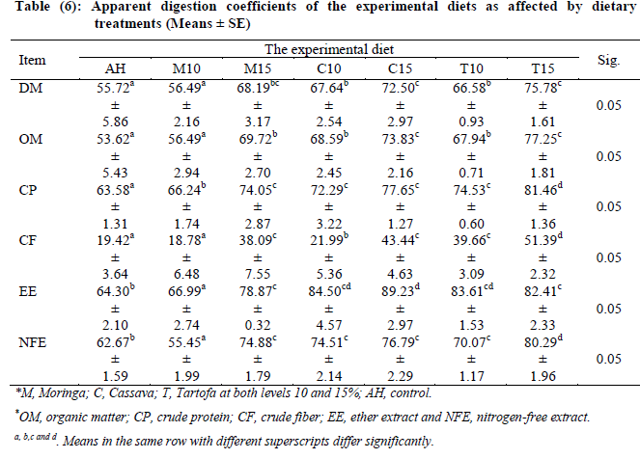**Table 1: Apparent Digestion coefficients of the experimental diets as affected by Dietary treatments (Means +Standard Error)**

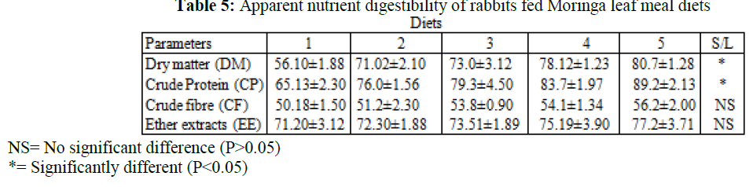**Table 2: Apparent Nutrient Digestibility of Rabbits fed Moringa leaf meal diets**

***Source: Umaru et al., (2017***

**Neem *(Azadirachta indica)***

Neem is a versatile herb with various health benefits. Its leaves and seeds are often used in rabbit feeds. Neem has antimicrobial, antiparasitic, and immune-stimulating properties. Incorporating neem in rabbit diets helps in preventing diseases, improving digestion, and promoting growth (Ngbede *et al.,* 2017).

**Plantain Leaves *(Musa species)***

Plantain leaves are known for their antimicrobial properties and may help in maintaining healthy gut function in rabbits (Ebeye *et al.,* 2020)

**Scent Leaf (Ocimum gratissimum)**

Scent leaf, also known as basil, is rich in antioxidants and has been suggested to have antibacterial and antifungal properties. Some rabbit owners believe it can benefit overall health (Igbasan *et al.,* 2019)

**Pawpaw *(Carica papaya)***

Different parts of the pawpaw plant, including the leaves, seeds, and fruits, are used in rabbit nutrition. Pawpaw leaves contain enzymes, vitamins, and phytochemicals that aid in digestion, prevent coccidiosis, and enhance weight gain in rabbits (Audu *et al.,* 2019).

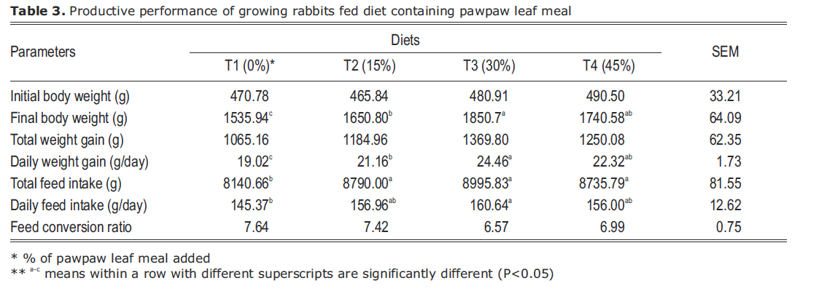**Table 3: Productive Performance of growing Rabbits fed diets containing papaw leaf meal**

***Source: Audu et al., (2019).***

**Ginger *(Zingiber officinale)***

Ginger possesses anti-inflammatory and antimicrobial activities. It can be used as a natural alternative to antibiotics in rabbit production. Ginger extracts have shown to improve weight gain and feed conversion efficiency in rabbits (Marx, 2015).

**Turmeric *(Curcuma longa)***

Turmeric contains curcumin, a natural compound with antioxidant and anti-inflammatory properties. It has been found to improve growth performance, enhance immune response, and protect against coccidial infections in rabbits (Hewlings & Kalman, 2017).

**Aloe vera**

Aloe vera gel is known for its wound healing and immune-modulatory properties. It can be used topically to treat skin infections or as a supplement in rabbit feed to improve growth and overall health (Iwu, 2014).

**Garlic *(Allium sativum)***

Garlic is a potent herb with various health-promoting properties. It contains allicin, a compound with antimicrobial and immune-boosting effects. Including garlic in rabbit diets improves feed utilization, prevents gastrointestinal diseases, and enhances growth performance (Nworgu *et al.,* 2018).

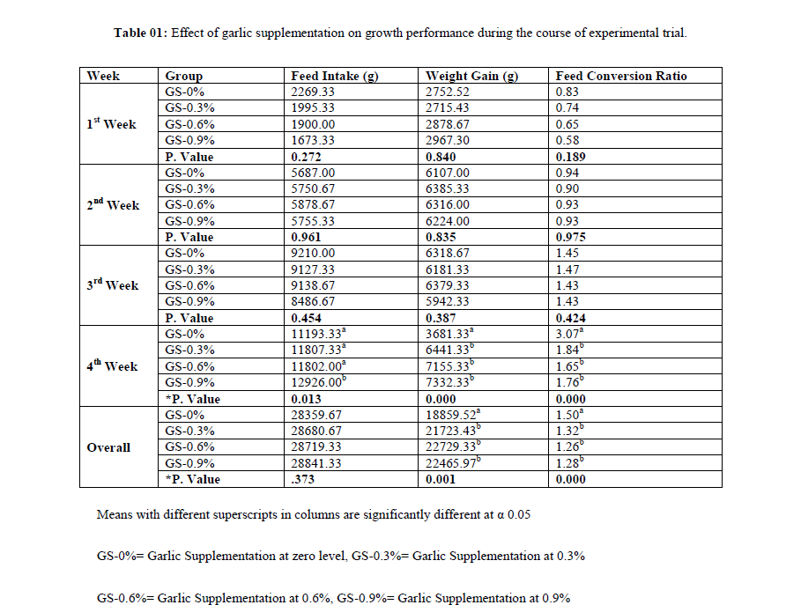**Table 4: Effect of Garlic supplementation on growth performance of Rabbits**

***Source: Nworgu et al., (2018).***

**Bitterleaf *(Vernonia amygdalina)***

Vernonia leaves are commonly used in rabbit nutrition due to their high protein and fiber content. They possess anthelmintic properties, which help in controlling parasitic infections in rabbits. Including *vernonia* in diets results in improved growth, feed conversion efficiency, better reproductive ability and better carcass characteristics (Ali *et al.,* 2020).

Table 5: Libido score and semen indices of Rabbits bucks fed dietary levels of *Vernonia* amygdalina leaf meal

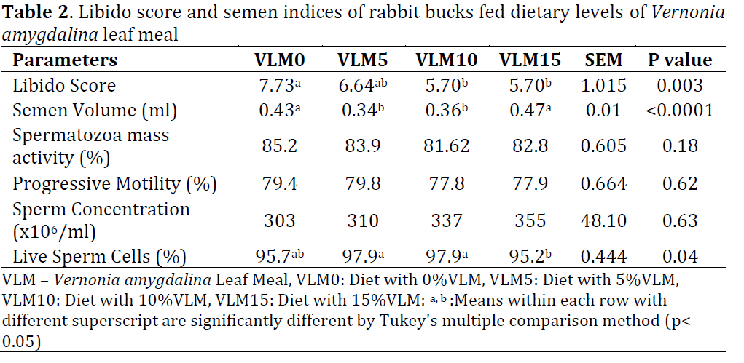

**FORMS OF HERBS ADMINISRATION TO RABBITS**

Herbs can be presented to rabbits in various forms to ensure their consumption. Here are some common forms:

**Fresh Herbs:** Providing fresh herbs is an excellent way to offer rabbits a variety of flavors and textures. These can be given directly as a part of their daily diet. Example of fresh herbs suitable for rabbits include; pawpa leaves (RSPCA, 2020).

**Dried Herbs:** Drying herbs can help preserve them for longer periods, especially when fresh herbs are out of season. Dried herbs can be offered as occasional treats or mixed into their hay. The herbs are completely dry before storing to prevent mold growth, sometimes grounded and mixed with rabbit concentrates feed (Storm, 2019).

**Herbal Hay Mixes:** Incorporating herbs into hay is another way to offer a blend of flavors and scents. It can encourage rabbits to forage, which promotes natural behavior. Several commercial brands offer hay mixes that include herbs like chamomile, marigold, or nettle HRS (2020).

**Herbal Pellets or Treats:** Some rabbit food manufacturers produce pellets or treats infused with herbs. These can be given as a supplement to their regular diet or as a special reward. However, it's important to check the ingredients and ensure the pellets or treats are free from harmful additives or excessive sugars.

**Herbal Toys**: Certain herbal toys, such as balls or mats made of natural fibers and filled with fragrant herbs, can provide both mental stimulation and a source of healthy nibbling. These toys often include herbs like lavender, rose petals, or chamomile (RSPCA, 2020).

**EMPIRICAL REVIEW ON THE EFFECT OF HERBS ON RABBIT PERFORMANCE**

Rabbits are small livestock animals that have gained significant attention in the agriculture sector due to their high reproductive potential and efficient feed conversion. To improve feed utilization and growth performance, various strategies have been explored, including the use of natural additives such as indigenous herbs. Nigeria, with its rich biodiversity, offers a wide range of herbs that have the potential to enhance rabbit performance. Although, there is limited research specifically focusing on the effect of herbs on the performance of rabbits. However, some studies have been conducted on the impact of various herbs and plant extracts on the performance of Rabbits in general.

Njidda *et al.,* (2010) investigated the effects of dietary supplementation with *Moringa oleifera* leaf meal on the growth performance of rabbits. Results showed that rabbits fed diets containing Moringa leaf meal had improved average daily weight gain and feed conversion ratio compared to those on a control diet. *Moringa oleifera* is an indigenous herb commonly found in Nigeria. Another study conducted by Thomas *et al.,* (2014) evaluated the effects of feeding rabbits with diets supplemented with garlic *(Allium sativum)* powder. The results showed that rabbits fed with garlic-supplemented diets had significantly higher daily feed intake and improved growth performance compared to the control group. Adewunmi *et al.,* (2015) also investigated the effect of *Thymus vulgaris* (thyme) essential oil on the performance of rabbits. The results revealed that rabbits fed with thyme essential oil-supplemented diets had improved weight gain and feed conversion efficiency.

In another study by Akinfemi *et al.,* (2017), the effects of *Vernonia amygdalina* (bitter leaf) extract on the growth performance of rabbits were examined. Results showed that rabbits fed with bitter leaf extract had better feed utilization, weight gain, and feed conversion ratio compared to those on a control diet.

Adeyemi *et al., (*2014) also investigated the impact of Aloe vera and *Aframomum melegueta* extracts on the growth performance and nutrient digestibility of rabbits, showing positive effects on feed intake and feed conversion ratio.

Omole *et al.,* (2011) researched on the inclusion of *Azadirachta indica* (Neem) leaf meal as a feed additive in rabbit diets. The study reported improved growth performance and reduced feed conversion ratio with the addition of Neem leaf meal.

Agbaje *et al.,* (2019) also studied the effects of turmeric *(Curcuma longa)* supplementation on growth performance, hematological parameters, and carcass yield of rabbits were examined. The results indicated that turmeric supplementation improved growth performance and feed conversion efficiency.

Ihezue *et al.,* (2007) investigated the effect of *Garcinia kola* (Bitter kola) on the performance and blood profile of growing rabbits. The study demonstrated that the inclusion of Bitter kola improved feed intake and growth performance.

Igbasan *et al.,* (2019) evaluated the growth performance, hematology, serum biochemistry, and carcass composition of rabbits fed diets containing *Dennettia tripetala* (Pepper fruit) leaf meal. The supplementation of Pepper fruit leaf meal resulted in improved growth performance and carcass composition. Adu *et al.*, (2017) investigated the performance, serum cholesterol, and hematology of rabbits fed diets supplemented with ginger *(Zingiber officinale)* and garlic *(Allium sativum).* The results showed an improved growth performance and favorable blood parameters. Ebeye *et al., (*2020) also examined the effect of *Carica papaya* (pawpaw) leaf meal on the growth performance, hematological, and serum biochemical indices of rabbits. Pawpaw leaf meal inclusion resulted in improved growth performance and hematological parameters. Yakubu *et al.,* 2013 also investigated the response of growing rabbits to diets supplemented with *Thaumatococcus daniellii* (African sweetleaf) leaf meal. The research revealed that *Thaumatococcus daniellii* leaf meal had positive effects on growth performance and feed conversion ratio.

**CONCLUSION**

Conclusively, the use of herbs in animal nutrition and production has become an area of concern among animal breeders and rabbits inclusively. Herbs are essential for the health status of the animals which invariably has positive impact on the general performance of rabbits. From this review, it could be deducted that herbs are good for rabbits. Although, it is important to note that while herbs may have potential benefits, further research is needed to fully validate their impact on rabbit performance under varying production conditions in Nigeria.

**REFERENCES**

Adejumobi, O. A. (2019). Hepatoprotective evaluation of *Vernonia amygdalina* leaf extract against carbon tetrachloride-induced hepatotoxicity in rats. *Journal of Basic and Clinical Physiology and Pharmacology*, 30(3), 1-7.

Adewunmi, M. O., Orisajo, S. B., Saba, A. B., Egbewande, O. A., Babayemi, Y. O., & Oni, A. O. (2015). Performance and carcass characteristics of weaned rabbits fed graded levels of the essential oil of *Thymus vulgaris* (thyme). *Journal of Animal Physiology and Animal Nutrition,* 99(1), 197-203.

Adeyemi KD, Ajanaku KO, Idowu SO. (2014). Effects of Aloe vera and *Aframomum melegueta* extracts on growth performance, nutrient digestibility, and haematological indices of rabbits. *Journal of Animal Physiology and Animal Nutrition*;98(6):1072-1078. doi:10.1111/jpn.12239

Adu OA, Adetoso BO, Ojebiyi O. (2017) Performance, serum cholesterol, and hematology of growing rabbits fed diets supplemented with ginger (*Zingiber officinale)* and garlic *(Allium sativum*). *Tropical Animal Health and Production,* 49(4):825-831. doi:10.1007/s11250-017-1298-3

Agbaje M, Bamidele OO, Bamidele OS. (2019) Effects of turmeric (Curcuma longa) supplementation on growth performance, hematological parameters, and carcass yield of rabbits. *Veterinary World.;*12(6):866-870. doi:10.14202/vetworld.2019.866-870

Akinfemi, A., E.B., & Onunkwo, D. N. (2017). Growth indices, carcass qualities and survival rates of weaner rabbits fed maize, processed bitter *(Vernonia amygdalina)* leaf meals mixed at different proportions. *Nigerian Journal of Animal Science*, 19(1), 200-216.

Ali, F. M., Anthony, I. I., Imasuen, J. A., Okou, G. I., Sule, A. J., & Ajijola, O. O. (2020). Effects of different levels of *Vernonia amygdalina leaf* meal on the performance and carcass characteristics of rabbits. *Tropical Animal Health and Production,* 52(1), 21-28.

Audu, S., Yakubu, K., & Abubakar, U. (2019). Effects of pawpaw leaf meal on growth performance, carcass and haematological indices of broiler rabbits. *Nigerian Journal of Animal Research*, 1-11.

Azuike, E. C. (2021). Pharmacological activities, phytochemistry, and traditional uses of Vernonia amygdalina Del. from Nigeria: A comprehensive review. Journal of Ethnopharmacology, 265, 113372.

Carthey, A. J. R., Banks, P. B., & Dickman, C. R. (2012). Influence of habitat structure on habitat use by the European rabbit (*Oryctolagus cuniculus)* in Australia. *Mammalian Biology,* 77(3), 219-227.

Cash, B. D., & Epstein, M. S. (2016). Peppermint Oil. *U.S. Pharmacist,* 41(12), 30–32.

Diarra, A. (2019). Antidiabetic activity and phytochemical screening of extracts of *Morus mesozygia* stem bark. *Journal of Diabetes Research,* 2019, 1894362.

Ebeye OA, Adejumo DO, Rasheed B. (2020). Effect of pawpaw *(Carica papaya)* leaf meal on the growth performance, hematological, and serum biochemical indices of rabbits. *Journal of Animal Physiology and Animal Nutrition,* 104(6):1724-1731. doi:10.1111/jpn.13422

Erhirhie, O. E. (2018). Chemical composition and antioxidant activities of *Garcinia kola* seeds. *Journal of Traditional and Complementary Medicine,* 8(3), 440-445.

Fuentes-Montemayor, E., Goulson, D., Cavin, L., Wallace, J. M. R., & Park, K. J. (2011). Fragmented woodlands in agricultural landscapes: the influence of woodland character and landscape context on bats and their insect prey. *Agriculture, Ecosystems & Environment,* 141(3-4), 302-310.

García, M. L., Combes, S., & Gidenne, T. (2019). Rabbit: *The Other White Meat for Improved Livelihoods and Sustainable Production.* In Achieving Sustainable Production of Poultry Meat Volume 1 (pp. 267-309). Burleigh Dodds Science Publishing Limited.

Hewlings, S. J., & Kalman, D. S. (2017). Curcumin: A Review of Its Effects on Human Health. *Foods*, 6(10), 92.

Igbasan FA, Omole AJ, Bolu SA. (2019). Growth performance, hematology, serum biochemistry, and carcass composition of rabbits fed *Dennettia tripetala* leaf meal-based diets. *Journal of Applied Animal Research;*47(1):51-57. doi:10.1080/09712119.2018.1469852

Ihezue UH, Adeyemi SA, Akinola LA. (2007). Effect of *Garcinia kola* (Bitter kola) on the performance and blood profile of growing rabbits. *Animal Production Research Advances;*3(1):66-72.

Iwu, M. M. (2014). *Handbook of African Medicinal Plants* (2nd ed.). CRC Press.

Kamran, Z. (2019). Azadirachta indica (Neem): A plant of multiple biological and pharmacological activities. *Phytotherapy Research,* 33(7), 1689-1702.

Kogan, L. R., Adams, C. L., & Holmberg, T. (2012). Owner attachment and problem behaviors related to relinquishment and training techniques of dogs. *Journal of Applied Animal Welfare Science,* 15(1), 37-46.

Marx, W. (2015). Ginger—Mechanism of action in chemotherapy-induced nausea and vomiting: A review. *Critical Reviews in Food Science and Nutrition,* 57(1), 141-146.

Ngbede, S. O., Omamegbe, J. O., & Kingsley, K. S. (2017). Effect of neem *(Azadirachta indica)* leaf meal on growth rate, hematological parameters, nutrient utilization and economic viability of growing rabbits. *American Journal of Experimental Agriculture,* 16(4), 1-8.

Njidda, A. A., Okorie, K. C., & Aluwong, T. (2010). Growth performance and nutrient digestibility of broiler chicks fed diets containing graded levels of *Moringa oleifera* leaf meal. *International Journal of Poultry Science,* 9(4), 363-367.

Nworgu, F. C., Okeke, G. C., Anachuna, K. O., & Ngene, A. L. (2018). Effect of garlic (*Allium sativum)* supplement on growth performance, feed utilization and economics of rabbit production. *Sokoto Journal of Veterinary Sciences*, 16(1), 8-14.

Olusanya, O. M. (2020). Phytochemical, pharmacological, and toxicological profiles of Moringa oleifera leaves: An overview. *Journal of Pharmacognosy and Phytotherapy,* 12(1), 1-9.

Omole AJ, Yakubu MT, Ojiezeh TI. (2011) Evaluation of Azadirachta indica (Neem) leaf meal as feed additive in the diet of growing rabbits. *Journal of Animal Physiology and Animal Nutrition*;95(2):225-230. doi:10.1111/j.1439-0396.

Omole, J. G. (2019). Antimicrobial activities of ethanolic leaf extract of Ocimum gratissimum against clinical isolates of some multidrug-resistant bacteria and fungus. *Annals of Clinical Microbiology and Antimicrobials,* 18(1), 36.

Onyegbule, O. A. (2017). Pharmacological and toxicological aspects of Ocimum gratissimum Linn: An update. Asian Journal of Pharmaceutical Research, 7(2), 138-154.

Rahman, K. (2007). Garlic and Aging: New Insights into an Old Remedy. *Ageing Research Reviews*, 6(1), 36-45.

Stewart, J. E., Niel, K. P. V., & Wilsey, B. J. (2014). Lepus alleni, on the role of an important ecosystem engineer in Great Plains grasslands. *The American Midland Naturalist*, 171(2), 287-297.

Thomas, M., Thomas, M., Francis, S., & Joy, P. P. (2014). Effect of garlic powder supplementation on the performance and carcass traits of growing rabbits. *Journal of Animal Science Advances,* 4(7), 998-1002.

Umaru, H. A., Tuleun, L. T. G., Ibitoye, E. B., & Shuaibu, G. (2017). Performance and haematological characteristics of growing rabbits fed *Moringa oleifera* leaf meal. *Nigerian Journal of Animal Science,* 19(2), 351-359.

Yakubu MT, Igbokwe PE, Ahmadu P. (2013). Response of growing rabbits to diets with *Thaumatococcus daniellii* leaf meal supplementation. *Animal Science Journal*;84(7):521-525. doi:10.1111/asj.12010

Zaza, G. H. M. (2004). *Presentation on agricultural residues expert consultation on the utilization of agricultural residues.* Workshop organized by FAO, Cairo, Egypt. 6-8 June.

Zaza, G. H. M. (2005). *Effect of incorporation of biologically treated sugar beet pulp as a non-conventional feedstuff in the diet of growing rabbits.* Proc. 4th Intern. Conf. Rabbits Prod. in Hot Climates, Sharm El-Sheik, Egypt, 267-274

Zhang, S., He, L., & Lu, X. (2017). The cultural image of the rabbit in Chinese idioms. *International Journal of Languages, Literature and Linguistics*, 3(5), 262-267.

HRS (2020). House Rabbit Society, Safe Foods for Rabbits. *Retrieved from https://rabbit.org/suggested-vegetables-and-fruits-for-a-rabbit-diet/*

RSPCA Queensland. (2020). Feeding Your Rabbit*. Retrieved from https://www.rspcaqld.org.au/what-we-do/rabbit-nutrition-diet*

Storm, J. (2019). A Comprehensive Guide to Rabbit Nutrition. *Journal of Exotic Pet Medicine*, 30, 109-124. doi: 10.1053/j.jepm.2019.03.007